Image Transfer from ESP32 Cam to Console

ESP32 cam needs to be configured and initialized to capture images (see example). After properly initialized, function esp_camera_fb_get() will return a struct of frame buffer:

typedef struct {

    uint8_t * buf;              /*!< Pointer to the pixel data */

    size_t len;                 /*!< Length of the buffer in bytes */

    size_t width;               /*!< Width of the buffer in pixels */

    size_t height;              /*!< Height of the buffer in pixels */

    pixformat_t format;         /*!< Format of the pixel data */

    struct timeval timestamp;   /*!< Timestamp since boot of the first DMA buffer of the frame */

} camera_fb_t;

The frame buffer is at the buf pointer with the size of len. If it is properly configured, the buffer will be in the jpeg format. And these data can be transmitted as byte stream through serial port with Serial.write(fb->buf, fb->len);

ESP32 cam only has 3 pins dedicated for UART, as the figure below:

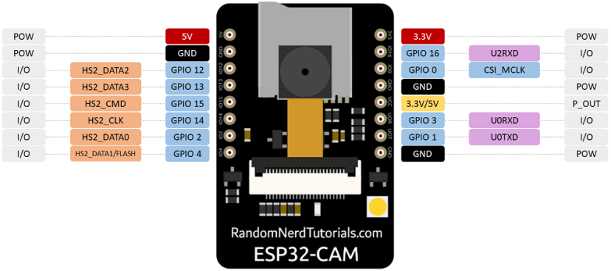

GPIO 1 and 3 are also used for sketch uploading. And because of the board configuration of ESP32 cam, this serial port isn’t compatible with console emulator like Teraterm. It can be properly interpreted by Arduino serial monitor if the board configuration is loaded. The problem according to [this post](https://forum.arduino.cc/t/esp32cam-ai-thinker-clone-strange-behaviour/1303127/3?u=e1berto) seems to be that ESP32 cam disabled DTR and RTS, and if these are used, the board will keep rebooting? However, the exact solution to configure Teraterm to fit with this setting is still unknown. This will also mess up the transmission if directly connected to HC-06 bluetooth module for serial transmission. Direct connection to other microcontrollers like MSP432P401R through UART seems to be fine though.

For now, in order to receive serial data on PC, [pyserial library](https://pyserial.readthedocs.io/en/latest/pyserial_api.html) is used. To resolve the issue of asserting DTR and RTS, it needs to initiate a port object and set dsrdtr to False before establishing the connection. For example:

    com = serial.Serial()

    com.port = port_name

    com.baudrate = baud

    com.timeout = 1

    com.dsrdtr = False

    com.open()

With connection properly established, it can receive bytes from serial port and save it as jpg file

Code on ESP32 cam

#include "esp_camera.h"

#include "Arduino.h"

#include "FS.h"                // SD Card ESP32

#include "SD_MMC.h"            // SD Card ESP32

#include "soc/soc.h"           // Disable brownour problems

#include "soc/rtc_cntl_reg.h"  // Disable brownour problems

#include "driver/rtc_io.h"

#include <EEPROM.h>            // read and write from flash memory

// define the number of bytes you want to access

#define EEPROM_SIZE 1

RTC_DATA_ATTR int bootCount = 0;

// Pin definition for CAMERA_MODEL_AI_THINKER

#define PWDN_GPIO_NUM     32

#define RESET_GPIO_NUM    -1

#define XCLK_GPIO_NUM      0

#define SIOD_GPIO_NUM     26

#define SIOC_GPIO_NUM     27

#define Y9_GPIO_NUM       35

#define Y8_GPIO_NUM       34

#define Y7_GPIO_NUM       39

#define Y6_GPIO_NUM       36

#define Y5_GPIO_NUM       21

#define Y4_GPIO_NUM       19

#define Y3_GPIO_NUM       18

#define Y2_GPIO_NUM        5

#define VSYNC_GPIO_NUM    25

#define HREF_GPIO_NUM     23

#define PCLK_GPIO_NUM     22

int pictureNumber = 0;

void setup() {

  WRITE_PERI_REG(RTC_CNTL_BROWN_OUT_REG, 0); //disable brownout detector

  Serial.begin(115200);

  Serial.setDebugOutput(true);

  camera_config_t config;

  config.ledc_channel = LEDC_CHANNEL_0;

  config.ledc_timer = LEDC_TIMER_0;

  config.pin_d0 = Y2_GPIO_NUM;

  config.pin_d1 = Y3_GPIO_NUM;

  config.pin_d2 = Y4_GPIO_NUM;

  config.pin_d3 = Y5_GPIO_NUM;

  config.pin_d4 = Y6_GPIO_NUM;

  config.pin_d5 = Y7_GPIO_NUM;

  config.pin_d6 = Y8_GPIO_NUM;

  config.pin_d7 = Y9_GPIO_NUM;

  config.pin_xclk = XCLK_GPIO_NUM;

  config.pin_pclk = PCLK_GPIO_NUM;

  config.pin_vsync = VSYNC_GPIO_NUM;

  config.pin_href = HREF_GPIO_NUM;

  config.pin_sscb_sda = SIOD_GPIO_NUM;

  config.pin_sscb_scl = SIOC_GPIO_NUM;

  config.pin_pwdn = PWDN_GPIO_NUM;

  config.pin_reset = RESET_GPIO_NUM;

  config.xclk_freq_hz = 20000000;

  config.pixel_format = PIXFORMAT_JPEG;

  pinMode(4, INPUT);

  digitalWrite(4, LOW);

  rtc_gpio_hold_dis(GPIO_NUM_4);

  if(psramFound()){

    config.frame_size = FRAMESIZE_UXGA; // FRAMESIZE_ + QVGA|CIF|VGA|SVGA|XGA|SXGA|UXGA

    config.jpeg_quality = 10;

    config.fb_count = 2;

  } else {

    config.frame_size = FRAMESIZE_SVGA;

    config.jpeg_quality = 12;

    config.fb_count = 1;

  }

  // Init Camera

  esp_err_t err = esp_camera_init(&config);

  if (err != ESP_OK) {

    Serial.printf("Camera init failed with error 0x%x", err);

    return;

  }

  // Serial.println("Starting SD Card");

  // delay(500);

  // if(!SD_MMC.begin()){

  //   Serial.println("SD Card Mount Failed");

  //   //return;

  // }

  // uint8_t cardType = SD_MMC.cardType();

  // if(cardType == CARD_NONE){

  //   Serial.println("No SD Card attached");

  //   return;

  // }

  camera_fb_t * fb = NULL;

  // Take Picture with Camera

  pinMode(4, OUTPUT);

  digitalWrite(4, HIGH);

  fb = esp_camera_fb_get();

  delay(1000);//This is key to avoid an issue with the image being very dark and green. If needed adjust total delay time.

  fb = esp_camera_fb_get();

  digitalWrite(4, LOW);

  if(!fb) {

    Serial.println("Camera capture failed");

    return;

  }

  // Path where new picture will be saved in SD Card

  // String path = "/picture" + String(pictureNumber) +".jpg";

  // fs::FS &fs = SD_MMC;

  // Serial.printf("Picture file name: %s\n", path.c_str());

  // File file = fs.open(path.c_str(), FILE_WRITE);

  // if(!file){

  //   Serial.println("Failed to open file in writing mode");

  // }

  // else {

  //   file.write(fb->buf, fb->len); // payload (image), payload length

  //   Serial.printf("Saved file to path: %s\n", path.c_str());

  //   Serial.printf("%u\n", *fb->buf);

  //   EEPROM.write(0, pictureNumber);

  //   EEPROM.commit();

  // }

  // file.close();

  Serial.printf("transmission started\n");

  Serial.printf("%u\n",fb->len);

  Serial.write(fb->buf, fb->len);

  Serial.printf("\ntransmission ends\n");

  esp_camera_fb_return(fb);

  delay(1000);

  // Turns off the ESP32-CAM white on-board LED (flash) connected to GPIO 4

  pinMode(4, OUTPUT);

  digitalWrite(4, LOW);

  rtc_gpio_hold_en(GPIO_NUM_4);

  delay(500);

  esp_deep_sleep_start();

}

void loop() {

}

Code of python script

import serial, time

import sys

if __name__ == '__main__':

    if len(sys.argv) != 3:

        print("python script serial_port baudrate")

        print("python -m serial.tools.list_ports")

        exit()

    port_name = sys.argv[1]

    baud = sys.argv[2]

    com = serial.Serial()

    com.port = port_name

    com.baudrate = baud

    com.timeout = 1

    com.dsrdtr = False

    com.open()

    #ser = serial.Serial(port_name, baudrate= baud, timeout = 2, dsrdtr=None)

    print("serial connected")

    while True:

        value = com.readline()

        line = str(value, encoding="UTF-8")

        print(line)

        if(value == b'transmission started\n'):

            value = com.readline()

            line = str(value, encoding="UTF-8")

            file_len = int(line)

            print(f'file size: {file_len} bytes')

            start = time.time()

            file_buf = com.read(file_len)

            with open("image.jpg", "wb") as f:

                f.write(file_buf)

            end = time.time()

            print(end - start)

            break